erl -sname foo -setcookie secret

P = spawn(wait, hello, []).

register(my_process, P).

{my_process, 'foo@LAPTOP-6A4S1HFF'} ! "hello".

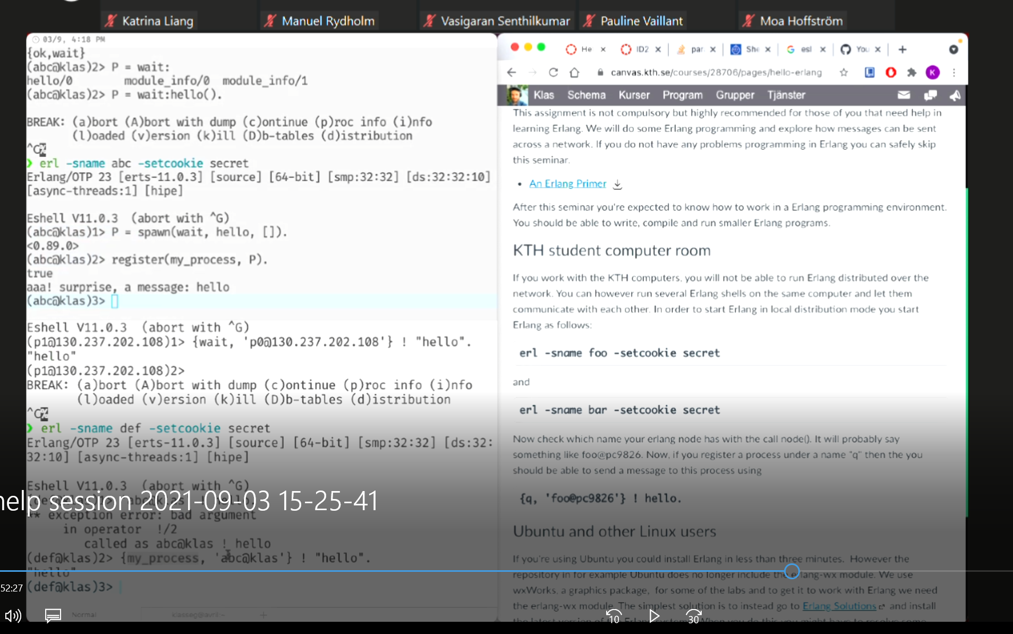

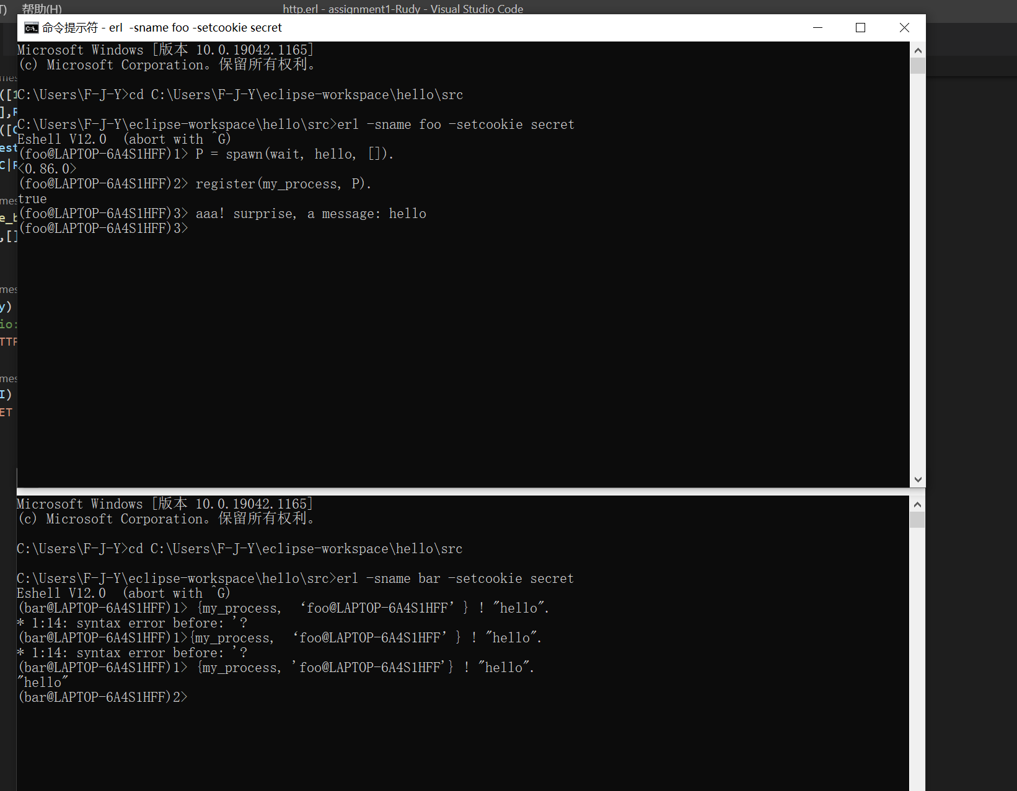

Ping-pong

Ping.erl:

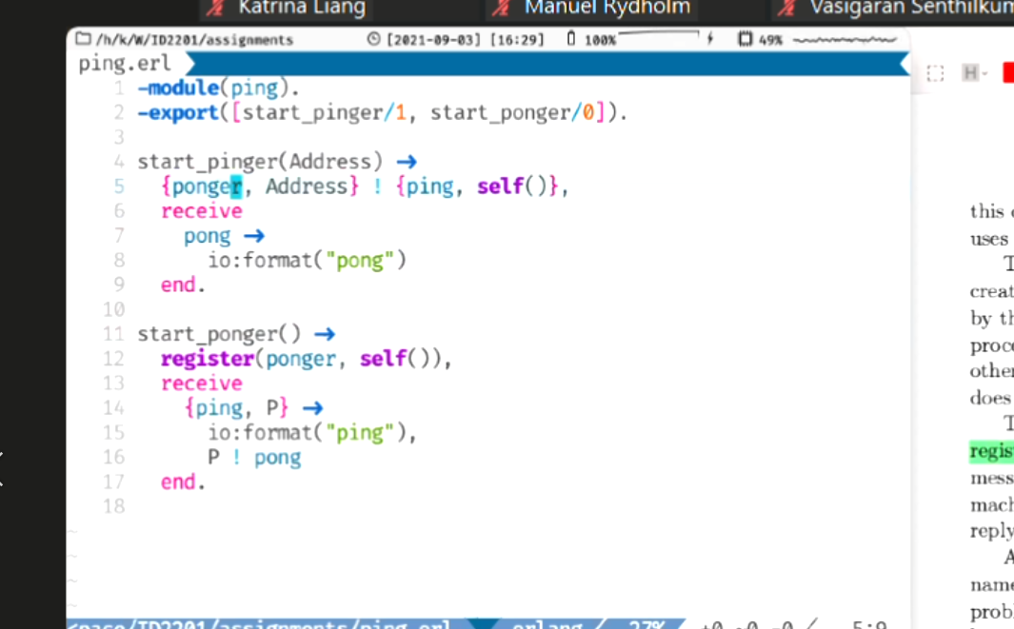

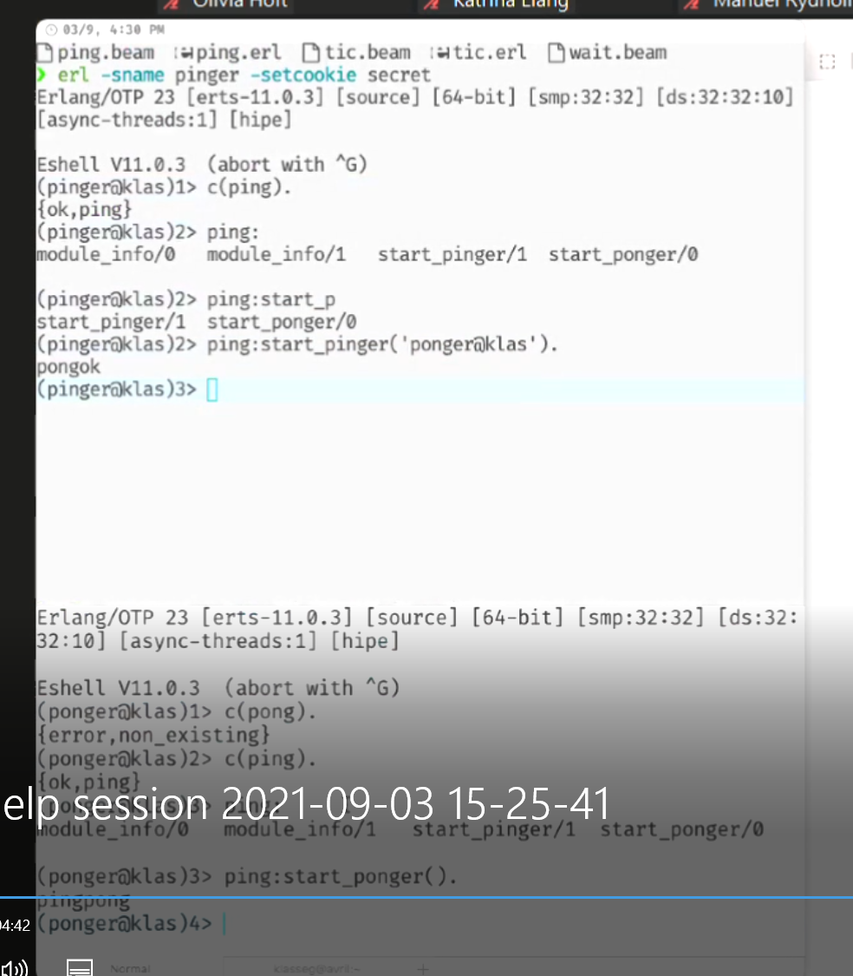

erl -sname foo -setcookie secret

rudy4:start(8080).

test2:bench(“localhost”, 8080).

test:bench(“LAPTOP-6A4S1HFF”, 8080).

test:bench("args", 8080).

reply:stop().

